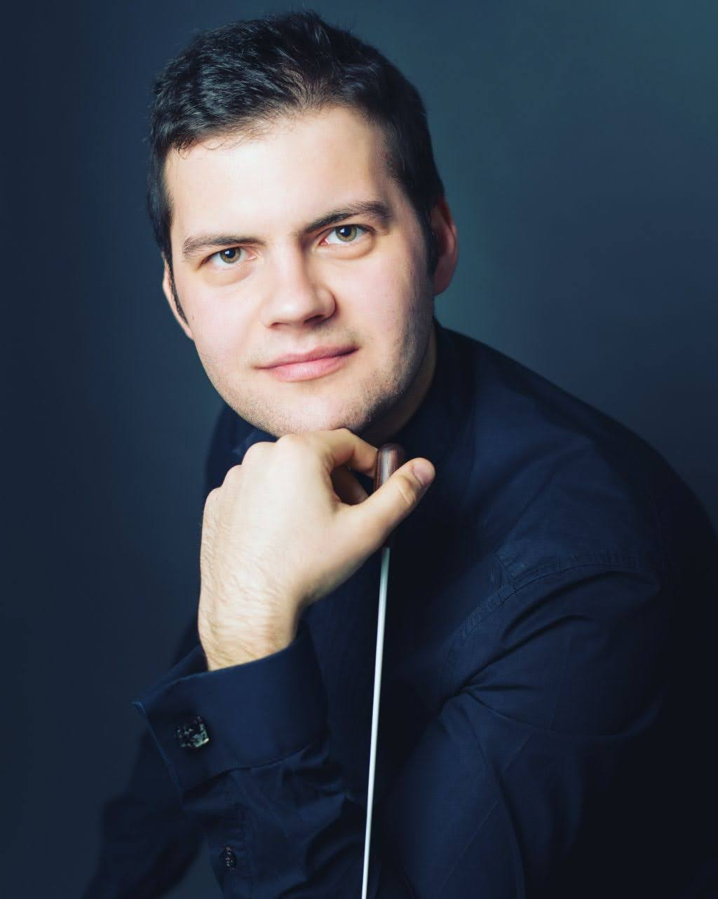
"Confident and fluid conducting baton of Arseniy Shkaptsov who, despite his young age, showed great mastery of the difficult repertoire by leading the orchestra in sudden changes of tempo and dynamics without ever leaving room for smearing and creating a wonderful ensemble with the piano in a balanced dialogue…" - Cremona sera

Arseniy Shkaptsov was recently appointed assistant conductor to Vladimir Fedoseev (Tchaikovsky Orchestra) and artistic director of the United Soloists Orchestra(Switzerland). Highlights of the 2022/23 season include his debut with the Arturo Toscanini Orchestra.

His mentors include such personalities as Paavo and Neeme Järvi, Daniele Gatti, and Vladimir Fedoseev.

His symphonic activity includes such orchestras as the Orchestra della Svizzera Italiana (Switzerland), Carlovy Vary Philharmonic Orchestra (Czech Republic), The Rousse Philharmonic Orchestra (Bulgaria), Tchaikovksy Symphony Orchestra (Russia), Orchestra Giovanile Italiana (Italy), Baltic Sea Philharmonic (Germany), Orchestra del Teatro comunale San Teodoro (Italy), Estonian Youh Orchestra.

Arseniy has collaborated with extraordinary musicians such as Kurt Masur, Valery Gergiev, Vladimir Ashkenazy, Mario Venzago, Arturo Tamayo, Ennio Morricone, Marta Argerich, Mikhail Pletnev, Stefano Bollani, Jiulia Fischer, Gidon Kremer.

Arseniy grew up in the family of musicians, father is a conductor, mother is a violinist, completed his studies in Moscow (Central Music School) and in 2011 came to Switzerland to continue his studies in Lugano (Conservatorio della Svizzera Italiana) as bassoonist with Gabor Meszaros and in Zurich (Zurich University of the Arts) as conductor with Christof Brunner and Marc Kissoczy.

As a bassoonist Arseniy plays in major classical music festivals such as "Usedom Music Festival," "Schleswig-Holstein," "Beethovenfest," "Rheingau Musik Festival," "Sommerfest Bad Kissingen." He is called bassoonist in various orchestras such as "Orchestra della Svizzera italiana," "Basler Festival Orchestra," "Baltic Sea Philharmonic," "Kammerphilharmonie Graubuenden," "Orchestra Verdi," "Symphonisches Orchester Zürich," and others.

Arseniy is also active in jazz music. In 2018 he released the album "Canon" with the group "The Sharp Shock," and in October his album "Bassoonova" with music by A. Jobim was released, which immediately entered the ITunes charts as "Best Jazz Album" in Finland. Her album is regularly played on the radio in Brazil and Switzerland.
Arseniy aims to promote diversity and bring together cultures and traditions through music. In 2017, he founded an association to support and promote young artists.

